Learner Guide

Module 8 – Machine Learning
Occupational Certificate: Artificial Intelligence Software Developer

Module # | 251201-002-00-KM-08
NQF Level | 5
Notional hours | 160
Credit(s) | 16
Curriculum Code | 251201002
Qualification Title | Occupational Certificate: Artificial Intelligence Software Developer
Development  Quality Partner | MICT SETA
Occupation or Specialization | AI Software Developer
Associated Occupation | Software Developer

CONTACT INFORMATION:
Name
Contact Address
Telephone (H)
Telephone (W)
Facsimile
Cellular
E-mail

Note to the learner
This Learner Guide provides a comprehensive overview of the module. It is designed to improve the skills and knowledge of learners, and thus enabling them to effectively and efficiently complete specific tasks.
PURPOSE OF THE KNOWLEDGE MODULE
The main focus of the learning in this knowledge module is to build an understanding of artificial Intelligence, its definition and future, as well as the purpose and contribution of AI to society and business

Entry Requirements:
NQF 4

PROVIDER ACCREDITATION REQUIREMENTS FOR THE MODULE:

Physical Requirements:
The provider must have lesson plans and structured learning material or provide learners with access to structured learning material that addresses all the topics in all the knowledge modules as well as the applied knowledge in the practical skills.
QCTO/ MICT SETA requirements
Human Resource Requirements:
Lecturer/learner ratio of 1:20 (Maximum)
Qualification of lecturer (SME):
NQF 6 in industry recognised qualifications with 1 year’s experience in the IT industry
AI vendor certification (where applicable)
Assessors and moderators: accredited by the MICT SETA
Legal Requirements:
Legal (product) licences to use the software for learning and training (where applicable)
OHS compliance certificate
Ethical clearance (where necessary)
Exemptions
No exemptions, but the module can be achieved in full through a normal RPL process

Assessments:

The only way to establish whether you are competent and have accomplished the learning outcomes is through continuous assessments. This assessment process involves interpreting evidence about your ability to perform certain tasks. You will be required to perform certain procedures and tasks during the training programme and will be assessed on them to certify your competence.

This module includes assessments in the form of self-evaluations/activities and exercises. The exercises, activities and self-assessments will be done in pairs, groups or on your own. These exercises/activities or self-assessments (Learner workbook) must be handed to the facilitator. It will be added to your portfolio of evidence, which will be proof signed by your facilitator that you have successfully performed these tasks.

Listen carefully to the instructions of the facilitator and do the given activities in the time given to you.

TOPIC ELEMENTS TO BE COVERED INCLUDE:
KM-08-KT01 : Types of ML models
KM-08-KT02 : ML algorithm classification
KM-08-KT03 : Common ML algorithms
KM-08-KT04 : ML Workflow Process (Framework)
KM-08-KT05 : Business benefits of ML

SECTION 1: KM-08-KT01: Types of ML models
Learning Outcome
- KT0101 Binary classification model
- KT0102 Multiclass classification model
- KT0103 Regression classification model
- KT0104 ML features and labels
- KT0105 ML Advantages and disadvantages

- KT0101 Binary classification model

Binary classification is the task of classifying the elements of a set into two groups on the basis of a classification rule. Typical binary classification problems include:

- Medical testing to determine if a patient has certain disease or not;
- Quality control in industry, deciding whether a specification has been met;
- In information retrieval, deciding whether a page should be in the result set of a search or not.
Binary classification is dichotomization applied to a practical situation. In many practical binary classification problems, the two groups are not symmetric, and rather than overall accuracy, the relative proportion of different types of errors is of interest. For example, in medical testing, detecting a disease when it is not present (a false positive) is considered differently from not detecting a disease when it is present (a false negative).

Statistical classification is a problem studied in machine learning. It is a type of supervised learning, a method of machine learning where the categories are predefined, and is used to categorize new probabilistic observations into said categories. When there are only two categories the problem is known as statistical binary classification.

Some of the methods commonly used for binary classification are:

- Decision trees
- Random forests
- Bayesian networks
- Support vector machines
- Neural networks
- Logistic regression
- Probit model
Each classifier is best in only a select domain based upon the number of observations, the dimensionality of the feature vector, the noise in the data and many other factors. For example, random forests perform better than SVM classifiers for 3D point clouds.

- KT0102 Multiclass classification model

In machine learning, multiclass or multinomial classification is the problem of classifying instances into one of three or more classes (classifying instances into one of two classes is called binary classification).

While many classification algorithms (notably multinomial logistic regression) naturally permit the use of more than two classes, some are by nature binary algorithms; these can, however, be turned into multinomial classifiers by a variety of strategies.

Multiclass classification should not be confused with multi-label classification, where multiple labels are to be predicted for each instance.

The existing multi-class classification techniques can be categorized into (i) transformation to binary (ii) extension from binary and (iii) hierarchical classification.

Transformation to binary
This section discusses strategies for reducing the problem of multiclass classification to multiple binary classification problems. It can be categorized into one vs rest and one vs one. The techniques developed based on reducing the multi-class problem into multiple binary problems can also be called problem transformation techniques.
One-vs.-rest
One-vs.-rest (OvR or one-vs.-all, OvA or one-against-all, OAA) strategy involves training a single classifier per class, with the samples of that class as positive samples and all other samples as negatives. This strategy requires the base classifiers to produce a real-valued confidence score for its decision, rather than just a class label; discrete class labels alone can lead to ambiguities, where multiple classes are predicted for a single sample.
In pseudocode, the training algorithm for an OvR learner constructed from a binary classification learner L is as follows:
Inputs:
- L, a learner (training algorithm for binary classifiers)
- samples X
- labels y where y_{i} ∈ {1, … K} is the label for the sample X_{i}
Output:
- a list of classifiers f_{k} for k ∈ {1, …, K}
Procedure:
- For each k in {1, …, K}
  - Construct a new label vector z where z_{i} = y_{i} if y_{i} = k and z_{i} = 0 otherwise
  - Apply L to X, z to obtain f_{k}
Making decisions means applying all classifiers to an unseen sample x and predicting the label k for which the corresponding classifier reports the highest confidence score:

Although this strategy is popular, it is a heuristic that suffers from several problems. Firstly, the scale of the confidence values may differ between the binary classifiers. Second, even if the class distribution is balanced in the training set, the binary classification learners see unbalanced distributions because typically the set of negatives they see is much larger than the set of positives.

One-vs.-one
In the one-vs.-one (OvO) reduction, one trains K (K − 1) / 2 binary classifiers for a K-way multiclass problem; each receives the samples of a pair of classes from the original training set, and must learn to distinguish these two classes. At prediction time, a voting scheme is applied: all K (K − 1) / 2 classifiers are applied to an unseen sample and the class that got the highest number of "+1" predictions gets predicted by the combined classifier.
Like OvR, OvO suffers from ambiguities in that some regions of its input space may receive the same number of votes.

Extension from binary
This section discusses strategies of extending the existing binary classifiers to solve multi-class classification problems. Several algorithms have been developed based on neural networks, decision trees, k-nearest neighbors, naive Bayes, support vector machines and extreme learning machines to address multi-class classification problems. These types of techniques can also be called algorithm adaptation techniques.

Neural network
Multiclass perceptrons provide a natural extension to the multi-class problem. Instead of just having one neuron in the output layer, with binary output, one could have N binary neurons leading to multi-class classification. In practice, the last layer of a neural network is usually a softmax function layer, which is the algebraic simplification of N logistic classifiers, normalized per class by the sum of the N-1 other logistic classifiers.

Extreme learning machines
Extreme learning machines (ELM) is a special case of single hidden layer feed-forward neural networks (SLFNs) wherein the input weights and the hidden node biases can be chosen at random. Many variants and developments are made to the ELM for multiclass classification.

k-nearest neighbours
k-nearest neighbors kNN is considered among the oldest non-parametric classification algorithms. To classify an unknown example, the distance from that example to every other training example is measured. The k smallest distances are identified, and the most represented class by these k nearest neighbours is considered the output class label.

Naive Bayes
Naive Bayes is a successful classifier based upon the principle of maximum a posteriori (MAP). This approach is naturally extensible to the case of having more than two classes, and was shown to perform well in spite of the underlying simplifying assumption of conditional independence.

Decision trees
Decision tree learning is a powerful classification technique. The tree tries to infer a split of the training data based on the values of the available features to produce a good generalization. The algorithm can naturally handle binary or multiclass classification problems. The leaf nodes can refer to any of the K classes concerned.
Support vector machines
Support vector machines are based upon the idea of maximizing the margin i.e. maximizing the minimum distance from the separating hyperplane to the nearest example. The basic SVM supports only binary classification, but extensions have been proposed to handle the multiclass classification case as well. In these extensions, additional parameters and constraints are added to the optimization problem to handle the separation of the different classes.

Hierarchical classification
Hierarchical classification tackles the multi-class classification problem by dividing the output space i.e. into a tree. Each parent node is divided into multiple child nodes and the process is continued until each child node represents only one class. Several methods have been proposed based on hierarchical classification.

- KT0103 Regression classification model

What is regression model and classification model?

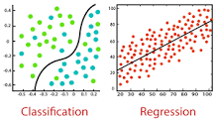

The main difference between Regression and Classification algorithms that Regression algorithms are used to predict the continuous values such as price, salary, age, etc. and Classification algorithms are used to predict/Classify the discrete values such as Male or Female, True or False, Spam or Not Spam, etc.

What is regression classification?
Classification and Regression are two major prediction problems that are usually dealt with in Data mining and machine learning. Classification is the process of finding or discovering a model or function which helps in separating the data into multiple categorical classes i.e. discrete values.

Can regression models be used for classification?
A probability-predicting regression model can be used as part of a classifier by imposing a decision rule - for example, if the probability is 50% or more, decide it's a cat. Logistic regression predicts probabilities, and is therefore a regression algorithm.

- KT0104 ML features and labels

What is feature extraction in ML?

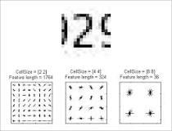

Feature extraction for machine learning and deep learning. Feature extraction refers to the process of transforming raw data into numerical features that can be processed while preserving the information in the original data set. It yields better results than applying machine learning directly to the raw data.

What is a ML feature store?



Amazon SageMaker Feature Store is a fully managed, purpose-built repository to store, update, retrieve, and share machine learning (ML) features. Features are the attributes or properties models use during training and inference to make predictions.

What is (supervised) machine learning? Concisely put, it is the following:
- ML systems learn how to combine input to produce useful predictions on never-before-seen data.
Let's explore fundamental machine learning terminology.
Labels
A label is the thing we're predicting—the y variable in simple linear regression. The label could be the future price of wheat, the kind of animal shown in a picture, the meaning of an audio clip, or just about anything.
Features
A feature is an input variable—the x variable in simple linear regression. A simple machine learning project might use a single feature, while a more sophisticated machine learning project could use millions of features, specified as:
x1,x2,...xN
In the spam detector example, the features could include the following:
- words in the email text
- sender's address
- time of day the email was sent
- email contains the phrase "one weird trick."
Examples
An example is a particular instance of data, x. (We put x in boldface to indicate that it is a vector.) We break examples into two categories:
- labeled examples
- unlabeled examples
A labeled example includes both feature(s) and the label. That is:
labeled examples: {features, label}: (x, y)
Use labeled examples to train the model. In our spam detector example, the labeled examples would be individual emails that users have explicitly marked as "spam" or "not spam."
For example, the following table shows 5 labeled examples from a data set containing information about housing prices in California:
housingMedianAge  (feature) | totalRooms  (feature) | totalBedrooms  (feature) | medianHouseValue  (label)
15 | 5612 | 1283 | 66900
19 | 7650 | 1901 | 80100
17 | 720 | 174 | 85700
14 | 1501 | 337 | 73400
20 | 1454 | 326 | 65500
An unlabeled example contains features but not the label. That is:
unlabeled examples: {features, ?}: (x, ?)
Here are 3 unlabeled examples from the same housing dataset, which exclude medianHouseValue:
housingMedianAge  (feature) | totalRooms  (feature) | totalBedrooms  (feature)
42 | 1686 | 361
34 | 1226 | 180
33 | 1077 | 271
Once we've trained our model with labeled examples, we use that model to predict the label on unlabeled examples. In the spam detector, unlabeled examples are new emails that humans haven't yet labeled.
Models
A model defines the relationship between features and label. For example, a spam detection model might associate certain features strongly with "spam". Let's highlight two phases of a model's life:
- Training means creating or learning the model. That is, you show the model labeled examples and enable the model to gradually learn the relationships between features and label.
- Inference means applying the trained model to unlabeled examples. That is, you use the trained model to make useful predictions (y'). For example, during inference, you can predict medianHouseValue for new unlabeled examples.

- KT0105 ML Advantages and disadvantages
Amidst all the hype around Big Data, we keep hearing the term “Machine Learning”. Not only does it offer a remunerative career, it promises to solve problems and also benefit companies by making predictions and helping them make better decisions. In this blog, we will learn the Advantages and Disadvantages of Machine Learning. As we will try to understand where to use it and where not to use Machine learning.
So, let’s start the Advantages and Disadvantages of Machine Learning.
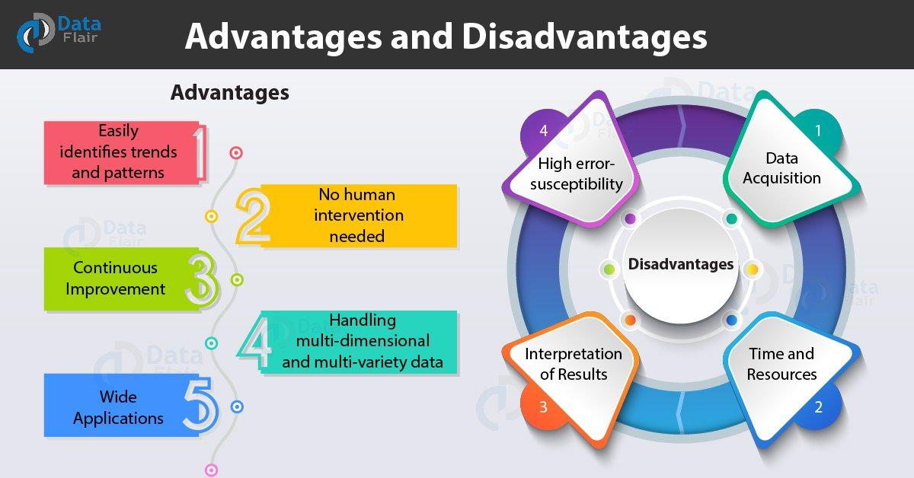
Advantages and Disadvantages of Machine Learning Language

Every coin has two faces, each face has its own property and features. It’s time to uncover the faces of ML. A very powerful tool that holds the potential to revolutionize the way things work.
Stay updated with latest technology trends
Advantages of Machine learning
1. Easily identifies trends and patterns
Machine Learning can review large volumes of data and discover specific trends and patterns that would not be apparent to humans. For instance, for an e-commerce website like Amazon, it serves to understand the browsing behaviors and purchase histories of its users to help cater to the right products, deals, and reminders relevant to them. It uses the results to reveal relevant advertisements to them.

2. No human intervention needed (automation)
With ML, you don’t need to babysit your project every step of the way. Since it means giving machines the ability to learn, it lets them make predictions and also improve the algorithms on their own. A common example of this is anti-virus softwares; they learn to filter new threats as they are recognized. ML is also good at recognizing spam.
3. Continuous Improvement
As ML algorithms gain experience, they keep improving in accuracy and efficiency. This lets them make better decisions. Say you need to make a weather forecast model. As the amount of data you have keeps growing, your algorithms learn to make more accurate predictions faster.
4. Handling multi-dimensional and multi-variety data
Machine Learning algorithms are good at handling data that are multi-dimensional and multi-variety, and they can do this in dynamic or uncertain environments.
5. Wide Applications
You could be an e-tailer or a healthcare provider and make ML work for you. Where it does apply, it holds the capability to help deliver a much more personal experience to customers while also targeting the right customers.

Disadvantages of Machine Learning
With all those advantages to its powerfulness and popularity, Machine Learning isn’t perfect. The following factors serve to limit it:
1. Data Acquisition
Machine Learning requires massive data sets to train on, and these should be inclusive/unbiased, and of good quality. There can also be times where they must wait for new data to be generated.
2. Time and Resources
ML needs enough time to let the algorithms learn and develop enough to fulfill their purpose with a considerable amount of accuracy and relevancy. It also needs massive resources to function. This can mean additional requirements of computer power for you.

3. Interpretation of Results
Another major challenge is the ability to accurately interpret results generated by the algorithms. You must also carefully choose the algorithms for your purpose.
4. High error-susceptibility
Machine Learning is autonomous but highly susceptible to errors. Suppose you train an algorithm with data sets small enough to not be inclusive. You end up with biased predictions coming from a biased training set. This leads to irrelevant advertisements being displayed to customers. In the case of ML, such blunders can set off a chain of errors that can go undetected for long periods of time. And when they do get noticed, it takes quite some time to recognize the source of the issue, and even longer to correct it.

What is the disadvantages of machine learning?

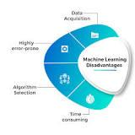

A Machine Learning problem can implement various algorithms to find a solution. It is a manual and tedious task to run models with different algorithms and identify the most accurate algorithm based on the results. This is a disadvantage.

Internal Assessment Criteria and Weight
- IAC0101 Types of ML are understood and described
- IAC0102 ML features and labels are understood and described

SECTION 2: KM-08-KT02:ML algorithm classification
Learning Outcome
- KT0201 Supervised Learning
- KT0202 Unsupervised Learning
- KT0203 Reinforcement Learning

- KT0201 Supervised Learning

Common classification algorithms are linear classifiers, support vector machines (SVM), decision trees, k-nearest neighbor, and random forest, which are described in more detail below. Regression is used to understand the relationship between dependent and independent variables.

Why is classification a supervised machine learning algorithm?

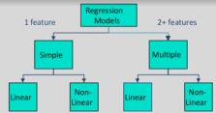

Supervised learning requires that the data used to train the algorithm is already labeled with correct answers. For example, a classification algorithm will learn to identify animals after being trained on a dataset of images that are properly labeled with the species of the animal and some identifying characteristics.

Are classification algorithms supervised learning?

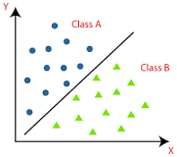

The Classification algorithm is a Supervised Learning technique that is used to identify the category of new observations on the basis of training data. In Classification, a program learns from the given dataset or observations and then classifies new observation into a number of classes or groups.

What is classification in supervised machine learning?

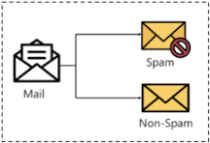

In machine learning, classification is a supervised learning concept which basically categorizes a set of data into classes. The most common classification problems are – speech recognition, face detection, handwriting recognition, document classification, etc.

- KT0202 Unsupervised Learning
Unsupervised Learning is a machine learning technique in which the users do not need to supervise the model. Instead, it allows the model to work on its own to discover patterns and information that was previously undetected. It mainly deals with the unlabelled data.
Unsupervised Learning Algorithms
Unsupervised Learning Algorithms allow users to perform more complex processing tasks compared to supervised learning. Although, unsupervised learning can be more unpredictable compared with other natural learning methods. Unsupervised learning algorithms include clustering, anomaly detection, neural networks, etc.

Unsupervised vs. supervised vs. semi-supervised learning
Unsupervised machine learning and supervised machine learning are frequently discussed together. Unlike supervised learning, unsupervised learning uses unlabeled data. From that data, it discovers patterns that help solve for clustering or association problems. This is particularly useful when subject matter experts are unsure of common properties within a data set. Common clustering algorithms are hierarchical, k-means, and Gaussian mixture models.
Semi-supervised learning occurs when only part of the given input data has been labeled. Unsupervised and semi-supervised learning can be more appealing alternatives as it can be time-consuming and costly to rely on domain expertise to label data appropriately for supervised learning.

- KT0203 Reinforcement Learning

Reinforcement learning (RL) is an area of machine learning concerned with how intelligent agents ought to take actions in an environment in order to maximize the notion of cumulative reward. Reinforcement learning is one of three basic machine learning paradigms, alongside supervised learning and unsupervised learning.

Reinforcement learning differs from supervised learning in not needing labelled input/output pairs be presented, and in not needing sub-optimal actions to be explicitly corrected. Instead the focus is on finding a balance between exploration (of uncharted territory) and exploitation (of current knowledge).[1] Partially supervised RL algorithms can combine the advantages of supervised and RL algorithms.[2]

The environment is typically stated in the form of a Markov decision process (MDP), because many reinforcement learning algorithms for this context use dynamic programming techniques.[3] The main difference between the classical dynamic programming methods and reinforcement learning algorithms is that the latter do not assume knowledge of an exact mathematical model of the MDP and they target large MDPs where exact methods become infeasible.

Internal Assessment Criteria and Weight
- IAC0201ML algorithm classifications are understood and described

SECTION 3: KM-08-KT03: Common ML algorithms
Learning Outcome
- KT0301 Supervised Learning:
- Linear Regression
- Naive Bayes
- Decision Trees
- Nearest neighbour
- Super Vector Machines SVM)
- Neural Networks
- KT0302 Unsupervised Learning:
- K-means clustering
- Association rule
- KT0303 Reinforcement Learning:
- Labels
- No labels
- KT0304 Reinforcement Learning
- Q-learning
- Temporal difference (TD)
- Deep adversarial networks

- KT0301 Supervised Learning:
- Linear Regression
- Naive Bayes
- Decision Trees
- Nearest neighbour
- Super Vector Machines SVM)
- Neural Networks
What is the Classification Algorithm?
The Classification algorithm is a Supervised Learning technique that is used to identify the category of new observations on the basis of training data. In Classification, a program learns from the given dataset or observations and then classifies new observation into a number of classes or groups. Such as, Yes or No, 0 or 1, Spam or Not Spam, cat or dog, etc. Classes can be called as targets/labels or categories.
Unlike regression, the output variable of Classification is a category, not a value, such as "Green or Blue", "fruit or animal", etc. Since the Classification algorithm is a Supervised learning technique, hence it takes labeled input data, which means it contains input with the corresponding output.

- y=f(x), where y = categorical output
The best example of an ML classification algorithm is Email Spam Detector.
The main goal of the Classification algorithm is to identify the category of a given dataset, and these algorithms are mainly used to predict the output for the categorical data.
Classification algorithms can be better understood using the below diagram. In the below diagram, there are two classes, class A and Class B. These classes have features that are similar to each other and dissimilar to other classes.
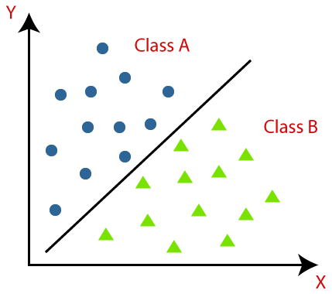
The algorithm which implements the classification on a dataset is known as a classifier. There are two types of Classifications:
- Binary Classifier: If the classification problem has only two possible outcomes, then it is called as Binary Classifier.
Examples: YES or NO, MALE or FEMALE, SPAM or NOT SPAM, CAT or DOG, etc.
- Multi-class Classifier: If a classification problem has more than two outcomes, then it is called as Multi-class Classifier.
Example: Classifications of types of crops, Classification of types of music.
Learners in Classification Problems:
In the classification problems, there are two types of learners:
- Lazy Learners: Lazy Learner firstly stores the training dataset and wait until it receives the test dataset. In Lazy learner case, classification is done on the basis of the most related data stored in the training dataset. It takes less time in training but more time for predictions.
Example: K-NN algorithm, Case-based reasoning
- Eager Learners:Eager Learners develop a classification model based on a training dataset before receiving a test dataset. Opposite to Lazy learners, Eager Learner takes more time in learning, and less time in prediction. Example: Decision Trees, Naïve Bayes, ANN.
Types of ML Classification Algorithms:
Classification Algorithms can be further divided into the Mainly two category:
- Linear Models
  - Logistic Regression
  - Support Vector Machines
- Non-linear Models
  - K-Nearest Neighbours
  - Kernel SVM
  - Naïve Bayes
  - Decision Tree Classification
  - Random Forest Classification

- KT0302 Unsupervised Learning:
- K-means clustering
- Association rule

Association rule learning is a rule-based machine learning method for discovering interesting relations between variables in large databases. It is intended to identify strong rules discovered in databases using some measures of interestingness.[1] In any given transaction with a variety of items, association rules are meant to discover the rules that determine how or why certain items are connected.

Based on the concept of strong rules, Rakesh Agrawal, Tomasz Imieliński and Arun Swami[2] introduced association rules for discovering regularities between products in large-scale transaction data recorded by point-of-sale (POS) systems in supermarkets. For example, the rule found in the sales data of a supermarket would indicate that if a customer buys onions and potatoes together, they are likely to also buy hamburger meat. Such information can be used as the basis for decisions about marketing activities such as, e.g., promotional pricing or product placements.

In addition to the above example from market basket analysis association rules are employed today in many application areas including Web usage mining, intrusion detection, continuous production, and bioinformatics. In contrast with sequence mining, association rule learning typically does not consider the order of items either within a transaction or across transactions.

The association rule algorithm itself consists of various parameters that can make it difficult for those without some expertise in data mining to execute, with many rules that are arduous to understand.

Despite this, association rule learning is a great system for predicting the behavior in data interconnections. This makes it a noteworthy technique for classification, or discovering patterns in data, when implementing machine learning methods.

What is k-means clustering and how it works?

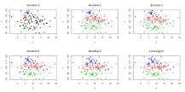

K-means clustering uses “centroids”, K different randomly-initiated points in the data, and assigns every data point to the nearest centroid. After every point has been assigned, the centroid is moved to the average of all of the points assigned to it.

What are the basic steps for k-means clustering?
Introduction to K-Means Clustering
- Step 1: Choose the number of clusters k. ...
- Step 2: Select k random points from the data as centroids. ...
- Step 3: Assign all the points to the closest cluster centroid. ...
- Step 4: Recompute the centroids of newly formed clusters. ...
- Step 5: Repeat steps 3 and 4.

- KT0303 Reinforcement Learning:
- Labels
- No labels

Reinforcement learning is a machine learning training method based on rewarding desired behaviors and/or punishing undesired ones. In general, a reinforcement learning agent is able to perceive and interpret its environment, take actions and learn through trial and error.

What is reinforcement learning examples?

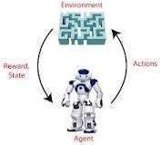

Hence, we can say that "Reinforcement learning is a type of machine learning method where an intelligent agent (computer program) interacts with the environment and learns to act within that." How a Robotic dog learns the movement of his arms is an example of Reinforcement learning.

Does reinforcement learning have labels?
Reinforcement learning is decision dependent. So, labels are given to sequences of dependent decisions. Supervised learning the choices are independent of each other, so labels are assigned to each decision.

Does reinforcement learning use unlabeled data?

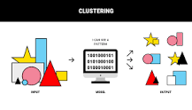

Reinforcement Machine Learning
Any data starts its life cycle as unlabeled: you collect it in the form of photos, video, audio or text. Then it undergoes the process of annotation, where human input adds labels to data points.

- KT0304 Reinforcement Learning
- Q-learning
- Temporal difference (TD)
- Deep adversarial networks
Q-learning is a model-free reinforcement learning algorithm to learn the value of an action in a particular state. It does not require a model of the environment (hence "model-free"), and it can handle problems with stochastic transitions and rewards without requiring adaptations.

For any finite Markov decision process (FMDP), Q-learning finds an optimal policy in the sense of maximizing the expected value of the total reward over any and all successive steps, starting from the current state. Q-learning can identify an optimal action-selection policy for any given FMDP, given infinite exploration time and a partly-random policy. "Q" refers to the function that the algorithm computes – the expected rewards for an action taken in a given state.

Reinforcement learning
Reinforcement learning involves an agent, a set of states , and a set of actions per state. By performing an action , the agent transitions from state to state. Executing an action in a specific state provides the agent with a reward (a numerical score).

The goal of the agent is to maximize its total reward. It does this by adding the maximum reward attainable from future states to the reward for achieving its current state, effectively influencing the current action by the potential future reward. This potential reward is a weighted sum of expected values of the rewards of all future steps starting from the current state.
As an example, consider the process of boarding a train, in which the reward is measured by the negative of the total time spent boarding (alternatively, the cost of boarding the train is equal to the boarding time). One strategy is to enter the train door as soon as they open, minimizing the initial wait time for yourself. If the train is crowded, however, then you will have a slow entry after the initial action of entering the door as people are fighting you to depart the train as you attempt to board. The total boarding time, or cost, is then:
- 0 seconds wait time + 15 seconds fight time
On the next day, by random chance (exploration), you decide to wait and let other people depart first. This initially results in a longer wait time. However, time-fighting other passengers are less. Overall, this path has a higher reward than that of the previous day, since the total boarding time is now:
- 5 second wait time + 0 second fight time
Through exploration, despite the initial (patient) action resulting in a larger cost (or negative reward) than in the forceful strategy, the overall cost is lower, thus revealing a more rewarding strategy.

Algorithm
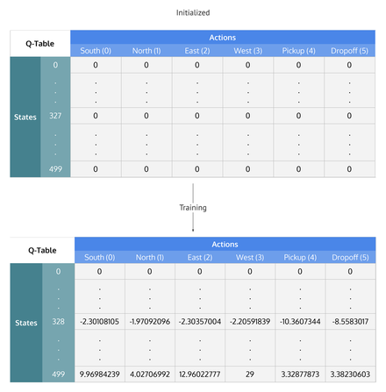
Q-Learning table of states by actions that is initialized to zero, then each cell is updated through training.
After steps into the future the agent will decide some next step. The weight for this step is calculated as , where (the discount factor) is a number between 0 and 1 () and has the effect of valuing rewards received earlier higher than those received later (reflecting the value of a "good start"). may also be interpreted as the probability to succeed (or survive) at every step .

Temporal difference (TD) learning refers to a class of model-free reinforcement learning methods which learn by bootstrapping from the current estimate of the value function. These methods sample from the environment, like Monte Carlo methods, and perform updates based on current estimates, like dynamic programming methods.[1]

While Monte Carlo methods only adjust their estimates once the final outcome is known, TD methods adjust predictions to match later, more accurate, predictions about the future before the final outcome is known.[2] This is a form of bootstrapping, as illustrated with the following example:

"Suppose you wish to predict the weather for Saturday, and you have some model that predicts Saturday's weather, given the weather of each day in the week. In the standard case, you would wait until Saturday and then adjust all your models. However, when it is, for example, Friday, you should have a pretty good idea of what the weather would be on Saturday – and thus be able to change, say, Saturday's model before Saturday arrives."

Temporal difference methods are related to the temporal difference model of animal learning.

Is generative adversarial network reinforcement learning?

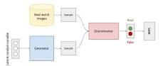

A type of deep neural network known as the generative adversarial networks (GAN) is a subset of deep learning models that produce entirely new images using training data sets using two of its components.

How does deep reinforcement learning use neural networks?
Deep reinforcement learning combines artificial neural networks with a framework of reinforcement learning that helps software agents learn how to reach their goals. That is, it unites function approximation and target optimization, mapping states and actions to the rewards they lead to.

Internal Assessment Criteria and Weight
- IAC0301Common ML algorithms are understood and described

SECTION 4: KM-08-KT04:ML Workflow Process (Framework)
Learning Outcome
- KT0401 Data Collection
- KT0402 Data Preparation
- KT0403 Choose a Model
- KT0404 Train the Model
- KT0405 Evaluate the Model
- KT0406 Parameter Tuning
- KT0407 Make Predictions

- KT0401 Data Collection
Data collection in machine learning
Data collection is the process of gathering and measuring information from countless different sources. In order to use the data we collect to develop practical artificial intelligence (AI) and machine learning solutions, it must be collected and stored in a way that makes sense for the business problem at hand.

What are the data collection methods?
7 Data Collection Methods Used in Business Analytics
- Surveys. Surveys are physical or digital questionnaires that gather both qualitative and quantitative data from subjects. ...
- Transactional Tracking. ...
- Interviews and Focus Groups. ...
- Observation. ...
- Online Tracking. ...
- Forms. ...
- Social Media Monitoring.

How does AI collect your data?
Artificial intelligence can give you analytics superpowers. AI is a collection of technologies that excel at extracting insights and patterns from large sets of data. AI can use those insights and patterns to make predictions about what drives outcomes. It can even learn to improve its predictions over time.

What is data collection examples?

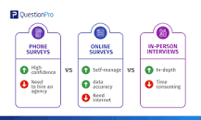

Essentially there are four choices for data collection – in-person interviews, mail, phone and online. There are pros and cons to each of these modes.

- KT0402 Data Preparation
What is Data Preparation for Machine Learning? Data preparation (also referred to as “data preprocessing”) is the process of transforming raw data so that data scientists and analysts can run it through machine learning algorithms to uncover insights or make predictions.

What is data preparation process?

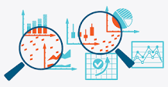

Data preparation is the process of collecting, cleaning, and consolidating data into one file or data table, primarily for use in analysis.

What are the data preparation techniques?
Data Preparation Steps in Detail
- Access the data.
- Ingest (or fetch) the data.
- Cleanse the data.
- Format the data.
- Combine the data.
- And finally, analyze the data.

Why is data preparation necessary in machine learning?
This is because of reasons such as: Machine learning algorithms require data to be numbers. Some machine learning algorithms impose requirements on the data. Statistical noise and errors in the data may need to be corrected.

- KT0403 Choose a Model

Different machine learning algorithms search for different trends and patterns. One algorithm isn’t the best across all data sets or for all use cases. To find the best solution, you need to conduct many experiments, evaluate machine learning algorithms, and tune their hyperparameters.
How to find the best solution
First, you choose, justify, and apply a model performance indicator to assess your model and justify the choice of an algorithm. Examples of model performance indicators include the F1 score, true positive rate, and within cluster sum of squared error.
Implement your algorithm in at least one deep-learning and at least one non-deep learning algorithm. Then, compare and document model performance.
Apply at least one more iteration in the process model that involves at least the feature creation task. Record the impact on model performance, such as data normalizing and principal component analysis (PCA). Depending on the algorithm class and data set size, you might choose specific technologies or frameworks to solve your problem.
As you evaluate algorithms, it's useful to know related terminology:
Term | Description
Descriptive analytics | Descriptive analytics is likely the most common type of analytics that is used to create dashboards and reports. It describes and summarizes events that already occurred. One example is a grocery store owner who wants to know how items of each product were sold in all stores within a region in the last five years.
Predictive analytics | Predictive analytics refers to using mathematical and statistical methods to forecast future outcomes. The grocery store owner wants to understand how many products can be sold in the next couple of months so that he can decide on inventory levels.
Prescriptive analytics | Prescriptive analytics is used to optimize business decisions by simulating scenarios that are based on a set of constraints. The grocery store owner wants to creating a staffing schedule for employees, but to do so, he must account for factors such as availability, vacation time, number of hours of work, and potential emergencies (constraints). He also must create a schedule that works for everyone and ensure that his business is able to function on a daily basis.
Supervised learning | Supervised learning teaches a model from labeled training data and helps you to make predictions about unseen or future data. During the training, you give the algorithm a dataset that contains correct answers (label y). Then, you validate the model accuracy with a test data set with correct answers. A data set must be split into training and test sets.
Classification | With classification, you're trying to predict one of a small number of discrete-valued outputs. For example, you might try to predict whether your label is binary (binary classification) or categorical (multiclass classification).
Regression | In regression, the goal of the learning problem is to predict continuous value output.
Unsupervised learning | Given a data set, try to find tendencies in the data by using techniques like clustering.
Feature | Feature is an attribute that is used as input for the model to train. Other names include dimension or column.
Bias | Bias is the expected difference between the parameters of a model that perfectly fits your data and the parameters that your algorithm learned. Low-bias algorithms, such as Decision Trees, K-nearest Neighbors, and Support Vector Machines, tend to find more complex patterns than high-bias algorithms.
Variance | Variance is how much the algorithm is impacted by the training data and how much the parameters change with new training data. Low-variance algorithm, such as Linear Regression, Logistic Regression, and Naive Bayes, tend to find less complex patterns than high-variance algorithms.
Underfitting | The model is too simple to capture the patterns within the data. The model performs poorly on data that it was trained on and on unseen data. High bias, low variance. High training error and high test error.
Overfitting | The model is too complicated or too specific, capturing trends that don't generalize. The model accurately predicts data that it was trained on but doesn't accurately predict unseen data. Low bias, high variance. Low training error and high test error.
Bias-Variance Trade-off | Bias-Variance Trade-off refers to finding a model with the right complexity, minimizing both the train and test error.
Train, validate, and test algorithms
Machine learning algorithms learn from examples. If you have good data, the more examples you provide, the better the model is at finding patterns in the data. However, be cautious of overfitting. As described in the first table, overfitting is where a model can accurately make predictions for data that it was trained on but can't generalize to other data.
Overfitting is why you split your data into training data, validation data, and test data. Validation data and test data are often referred to interchangeably, but they have distinct purposes.

What is model in machine learning?

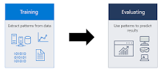

A machine learning model is a file that has been trained to recognize certain types of patterns. You train a model over a set of data, providing it an algorithm that it can use to reason over and learn from those data.

What is a machine model?
A machine learning model is an expression of an algorithm that combs through mountains of data to find patterns or make predictions. Fueled by data, machine learning (ML) models are the mathematical engines of artificial intelligence.

- KT0404 Train the Model
Training a model simply means learning (determining) good values for all the weights and the bias from labeled examples. In supervised learning, a machine learning algorithm builds a model by examining many examples and attempting to find a model that minimizes loss; this process is called empirical risk minimization.

Loss is the penalty for a bad prediction. That is, loss is a number indicating how bad the model's prediction was on a single example. If the model's prediction is perfect, the loss is zero; otherwise, the loss is greater. The goal of training a model is to find a set of weights and biases that have low loss, on average, across all examples. For example, Figure 3 shows a high loss model on the left and a low loss model on the right. Note the following about the figure:
- The arrows represent loss.
- The blue lines represent predictions.
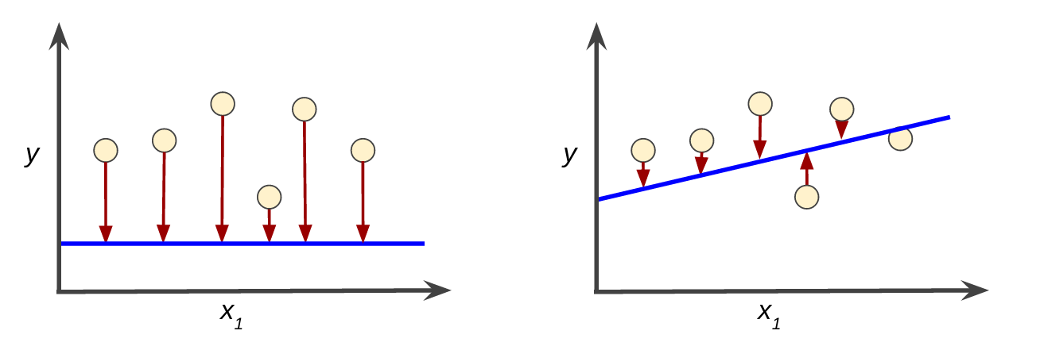
Figure 3. High loss in the left model; low loss in the right model.

Notice that the arrows in the left plot are much longer than their counterparts in the right plot. Clearly, the line in the right plot is a much better predictive model than the line in the left plot.
You might be wondering whether you could create a mathematical function—a loss function—that would aggregate the individual losses in a meaningful fashion.
Squared loss: a popular loss function
The linear regression models we'll examine here use a loss function called squared loss (also known as L₂ loss). The squared loss for a single example is as follows:
= the square of the difference between the label and the prediction
= (observation - prediction(x))²
= (y - y')²
Mean square error (MSE) is the average squared loss per example over the whole dataset. To calculate MSE, sum up all the squared losses for individual examples and then divide by the number of examples:
MSE=1N∑(x,y)∈D(y−prediction(x))2
where:
- (x,y) is an example in which
  - x is the set of features (for example, chirps/minute, age, gender) that the model uses to make predictions.
  - y is the example's label (for example, temperature).
- prediction(x) is a function of the weights and bias in combination with the set of features x.
- D is a data set containing many labeled examples, which are (x,y) pairs.
- N is the number of examples in D.
Although MSE is commonly-used in machine learning, it is neither the only practical loss function nor the best loss function for all circumstances.

- KT0405 Evaluate the Model
Why Evaluation is necessary for successful model?
Overfitting and underfitting are the two biggest causes for poor performance of machine learning algorithms.
Overfitting: Occurs when the Model performs well for a particular set of data(Known Data), and may therefore fail to fit additional data(Unknown Data) or predict future observations reliably.
Underfitting: Occurs when the model cannot adequately capture the underlying structure of the data.
Generalization: refers to how well the concepts learned by a machine learning model apply to specific examples not seen by the model when it was learning.
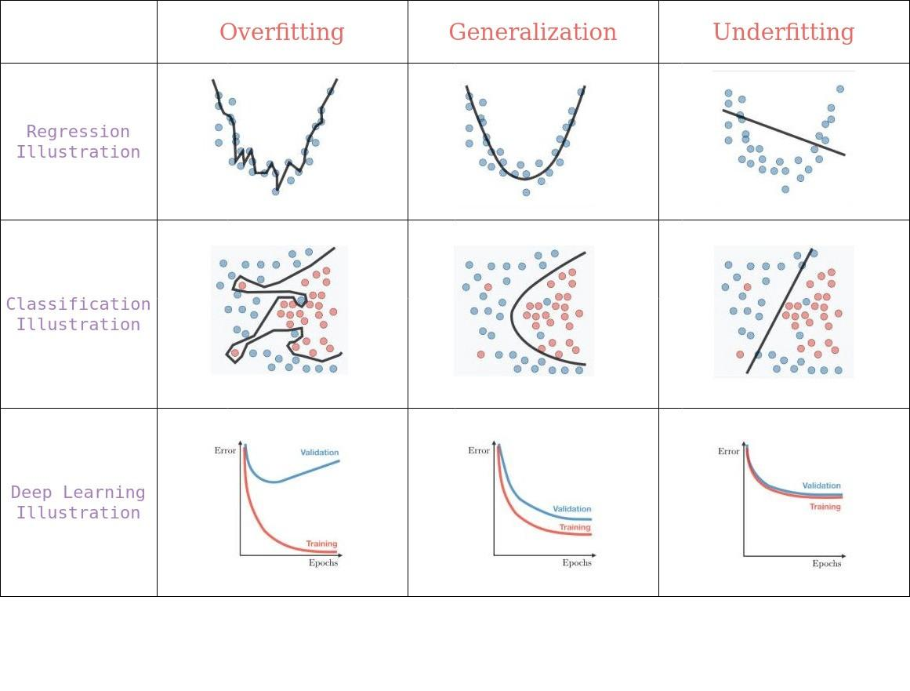
Overfitting vs Generalization vs Underfitting
In machine learning the learning of the target function from training data is described as inductive learning.Induction refers to learning general concepts from specific examples which is exactly the problem that supervised machine learning model aim to solve
Evaluation Metrics
There are different metrics for the tasks of classification, regression, ranking, clustering, topic modeling, etc. Some of the metrics are as follows:
- Classification Metrics (accuracy, precision, recall, F1-score, ROC, AUC, …)
- Regression Metrics (MSE, MAE)
- Ranking Metrics (MRR, DCG, NDCG)
- Statistical Metrics (Correlation)
- Computer Vision Metrics (PSNR, SSIM, IoU)
- NLP Metrics (Perplexity, BLEU score)
- Deep Learning Related Metrics (Inception score, Frechet Inception distance)
Note: For better understanding I have planned to focus Classification and Regression metrics in this Article.
1. Classification Metrics
Confusion Matrix
A confusion matrix is a table that is often used to describe the performance of a classification model (or “classifier”) on a set of test data for which the true values are known.
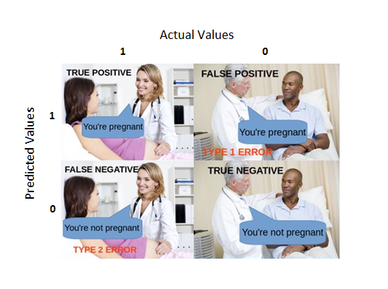
Confusion Matrix.
True Positive (TP) — A true positive is an outcome where the model correctly predicts the positive class.
True Negative (TN) — A true negative is an outcome where the model correctly predicts the negative class.
False Positive (FP) — A false positive is an outcome where the model incorrectly predicts the positive class.
False Negative (FN) — A false negative is an outcome where the model incorrectly predicts the negative class.

What is evaluate model in machine learning?

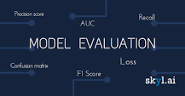

What is Model Evaluation? Model Evaluation is the process through which we quantify the quality of a system's predictions. To do this, we measure the newly trained model performance on a new and independent dataset. This model will compare labeled data with it's own predictions.

How do you evaluate a model?

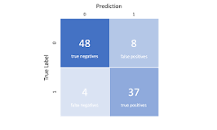

The three main metrics used to evaluate a classification model are accuracy, precision, and recall. Accuracy is defined as the percentage of correct predictions for the test data. It can be calculated easily by dividing the number of correct predictions by the number of total predictions.

- KT0406 Parameter Tuning
In machine learning, hyperparameter optimization or tuning is the problem of choosing a set of optimal hyperparameters for a learning algorithm. A hyperparameter is a parameter whose value is used to control the learning process. By contrast, the values of other parameters (typically node weights) are learned.

The same kind of machine learning model can require different constraints, weights or learning rates to generalize different data patterns. These measures are called hyperparameters, and have to be tuned so that the model can optimally solve the machine learning problem. Hyperparameter optimization finds a tuple of hyperparameters that yields an optimal model which minimizes a predefined loss function on given independent data. The objective function takes a tuple of hyperparameters and returns the associated loss. Cross-validation is often used to estimate this generalization performance.

Why do we do parameter tuning?
Hyperparameters tuning is crucial as they control the overall behavior of a machine learning model. Every machine learning models will have different hyperparameters that can be set. A hyperparameter is a parameter whose value is set before the learning process begins.

hat does tuning mean in machine learning?
Tuning is the process of maximizing a model's performance without overfitting or creating too high of a variance. In machine learning, this is accomplished by selecting appropriate “hyperparameters.” Hyperparameters can be thought of as the “dials” or “knobs” of a machine learning model.

- KT0407 Make Predictions

What is making predictions machine learning?
What does Prediction mean in Machine Learning? “Prediction” refers to the output of an algorithm after it has been trained on a historical dataset and applied to new data when forecasting the likelihood of a particular outcome, such as whether or not a customer will churn in 30 days.

Can machine learning make predictions?

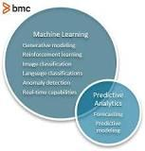

Both machine learning and predictive analytics are used to make predictions on a set of data about the future. Predictive analytics uses predictive modelling, which can include machine learning. Predictive analytics has a very specific purpose: to use historical data to predict the likelihood of a future outcome.

How do you make a prediction?



Predicting requires the reader to do two things: 1) use clues the author provides in the text, and 2) use what he/she knows from personal experience or knowledge (schema). When readers combine these two things, they can make relevant, logical predictions.

What is the best machine learning for prediction?
- Time Series Model. The time series model comprises a sequence of data points captured, using time as the input parameter. ...
- Random Forest. Random Forest is perhaps the most popular classification algorithm, capable of both classification and regression. ...
- Gradient Boosted Model (GBM) ...
- K-Means. ...
- Prophet.

Internal Assessment Criteria and Weight
- IAC0401ML workflow process is understood and applied

SECTION 5: KM-08-KT05 : Business benefits of ML 20%
Learning Outcome
- KT0501 Real-time business decision making
- KT0502 Eliminating manual tasks
- KT0503 Enhancing security and network performance
- KT0504 Improved business models and services
- KT0505 Reducing operating expense
- KT0506 Other

- KT0501 Real-time business decision making
Real-time business intelligence (RTBI) is a concept describing the process of delivering business intelligence (BI) or information about business operations as they occur. Real time means near to zero latency and access to information whenever it is required.[1]

The speed of today's processing systems has allowed typical data warehousing to work in real-time. The result is real-time business intelligence. Business transactions as they occur are fed to a real-time BI system that maintains the current state of the enterprise. The RTBI system not only supports the classic strategic functions of data warehousing for deriving information and knowledge from past enterprise activity, but it also provides real-time tactical support to drive enterprise actions that react immediately to events as they occur. As such, it replaces both the classic data warehouse and the enterprise application integration (EAI) functions. Such event-driven processing is a basic tenet of real-time business intelligence.

In this context, "real-time" means a range from milliseconds to a few seconds (5s) after the business event has occurred. While traditional BI presents historical data for manual analysis, RTBI compares current business events with historical patterns to detect problems or opportunities automatically. This automated analysis capability enables corrective actions to be initiated and/or business rules to be adjusted to optimize business processes.

RTBI is an approach in which up-to-a-minute data is analyzed, either directly from operational sources or feeding business transactions into a real time data warehouse and Business Intelligence system.

What is real time decision-making?
Real-Time Decision-Making is the ability to deliver decision support within the shortest possible time-frame using the best possible set of data and decision-making model to direct and report on business operations and interactions.

What does real time mean in business?
Real time means near to zero latency and access to information whenever it is required. The speed of today's processing systems has allowed typical data warehousing to work in real-time. The result is real-time business intelligence.

- KT0502 Eliminating manual tasks

How machine learning can help your business?

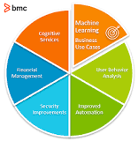

Running this data through a machine learning algorithm allows businesses to predict consumer purchasing habits, market trends, popular products, and so on, allowing retailers to make informed business decisions based on this predicted information.

What are the benefits of automating tasks in business and industry?
The benefits of automated operations are higher productivity, reliability, availability, increased performance, and reduced operating costs. Moving to lights-out operations yields a good return on investment. The benefits of automated systems can be a powerful motive for increasing service to your end users.

Why is machine learning important in today's business environment?
Data is the lifeblood of all business. Data-driven decisions increasingly make the difference between keeping up with competition or falling further behind. Machine learning can be the key to unlocking the value of corporate and customer data and enacting decisions that keep a company ahead of the competition.

What is manual processing?
Manual Processing means the process of Authorising the payments for a transaction manually and without any electronic confirmation through such mechanism as maybe stipulated by the Bank from time to time and requiring the use of such equipment as the Bank may specify.

How much time are you wasting on manual repetitive tasks?
A study found that 22% of an employee's time is spent on repetitive tasks. Over the course of a year, imagine how much money is wasted by workers spending time on manual tasks that can now be automated.

- KT0503 Enhancing security and network performance
Machine learning (ML) lets computers learn without being explicitly programmed. Put another way, machine learning teaches computers to do what people do: learn by experience. Machine learning is a domain within the broader field of artificial intelligence.

In security, machine learning continuously learns by analyzing data to find patterns so we can better detect malware in encrypted traffic, find insider threats, predict where “bad neighborhoods” are online to keep people safe when browsing, or protect data in the cloud by uncovering suspicious user behavior.

How does machine learning improve business performance?
Machine learning helps businesses use preventative maintenance to decrease equipment breakdowns and increase profits. With machine learning, businesses can leverage consumer data to build useful customer profiles, increase sales and improve brand loyalty.

How can machine learning be used in network security?
Machine learning can be applied in various ways in security, for instance, in malware analysis, to make predictions, and for clustering security events. It can also be used to detect previously unknown attacks with no established signature.

How does ML and AI help businesses use their enterprise data effectively?
How do Machine Learning and Artificial Intelligence (AI) technologiehelp businesses use their enterprise data effectively? They curate data quickly for multiple business scenarios. They collate the content of qualitative data (like text and images). They allow technologies to operate without data.

- KT0504 Improved business models and services
Businesses incorporate Machine Learning into their core processes for a variety of strategic reasons. Machine Learning can deliver benefits such as the ability to discover patterns and correlations, improve customer segmentation and targeting, and ultimately increase a business' revenue, growth and market position.

How does ML and AI help businesses use their enterprise data effectively?
How do Machine Learning and Artificial Intelligence (AI) technologiehelp businesses use their enterprise data effectively? They curate data quickly for multiple business scenarios. They collate the content of qualitative data (like text and images). They allow technologies to operate without data.

8 WAYS BUSINESSES CAN BENEFIT FROM MACHINE LEARNING

With all the buzz around big data, artificial intelligence, and machine learning (ML), enterprises are now becoming curious about the applications and benefits of machine learning in business. A lot of people have probably heard of ML, but do not really know what exactly it is, what business-related problems it can solve, or the value it can add to their business. ML is a data analysis process which leverages ML algorithms to iteratively learn from the existing data and help computers find hidden insights without being programmed for.
With Google, Amazon, and Microsoft Azure launching their Cloud Machine learning platforms, we have seen artificial intelligence and ML gaining prominence in the recent years. Surprisingly, we all have witnessed ML without actually knowing it. Some of the most common instances are 'Spam' detection by your email provider, and 'Image' or 'Face' tagging done by Facebook. While Gmail recognizes the selected words or the pattern to filter out spam, Facebook automatically tags uploaded images using image (face) recognition technique. Business benefits of AI and ML are numerous.

Top 8 Business Benefits of Machine Learning
Let us look at some of the most significant ML and artificial business benefits, starting with the sales and marketing sector.
- Simplifies Product Marketing and Assists in Accurate Sales Forecasts
ML helps enterprises in multiple ways to promote their products better and make accurate sales forecasts. ML offers huge advantages to sales and marketing sector, with the major ones being -
  - Massive Data Consumption from Unlimited Sources
ML virtually consumes unlimited amount of comprehensive data. The consumed data can then be used to constantly review and modify your sales and marketing strategies based on the customer behavioral patterns. Once your model is trained, it will be able to identify highly relevant variables. Consequently, you will be able to get focused data feeds by foregoing long and complicated integrations.
  - Rapid Analysis Prediction and Processing
The rate at which ML consumes data and identifies relevant data makes it possible for you to take appropriate actions at the right time. For instance, ML will optimize the best subsequent offer for your customer. Consequently, the customer will be able to see the right offer at a given point of time, without you actually investing time to plan and make the right ad visible for your customers.
  - Interpret Past Customer Behaviors
ML will let you analyze the data related to past behaviors or outcomes and interpret them. Therefore, based on the new and different data you will be able make better predictions of customer behaviors.
- Facilitates Accurate Medical Predictions and Diagnoses
In healthcare industry, ML helps in easy identification of high-risk patients, make near perfect diagnoses, recommend best possible medicines, and predict readmissions. These are predominantly based on the available datasets of anonymous patient records as well as the symptoms exhibited by them. Near accurate diagnoses and better medicine recommendations will facilitate faster patient recovery without the need for extraneous medications. In this way, ML makes it possible to improve patient health at minimal costs in the medical sector.
- Simplifies Time-Intensive Documentation in Data Entry
Data duplication and inaccuracy are the major issues confronted by organizations wanting to automate their data entry process. Well, this situation can be significantly improved by predictive modeling and machine learning algorithms. With this, machines can perform time-intensive data entry tasks, leaving your skilled resources free to focus on other value-adding duties.
- Improves Precision of Financial Rules and Models
ML also has a significant impact on the finance sector. Some of the common machine learning benefits in Finance include portfolio management, algorithmic trading, loan underwriting and most importantly fraud detection. In addition, according to a report on ‘The Future of Underwriting’ published by Ernst and Young, ML facilitates continual data assessments for detecting and analyzing anomalies and nuances. This helps in improving the precision of financial models and rules.
- Easy Spam Detection
Spam detection was one of the earliest problems solved by ML. Few years ago email providers made use of rule-based techniques to filter out spam. However, with the advent of ML, spam filters are making new rules using brain-like neural networks to eliminate spam mails. The neural networks recognize phishing messages and junk mail by evaluating the rules across a huge network of computers.
- Increases the Efficiency of Predictive Maintenance in the Manufacturing Industry
Manufacturing firms have corrective as well as preventive maintenance practices in place. However, these are often costly and inefficient. This is exactly where ML can be of great help. ML helps in the creation of highly efficient predictive maintenance plans. Following such predictive maintenance plans will minimize the chances of unexpected failures, thereby reducing unnecessary preventive maintenance activities.
- Better Customer Segmentation and Accurate Lifetime Value Prediction
Customer segmentation and lifetime value prediction are the major challenges faced by marketers today. Sales and marketing units will have enormous amounts of relevant data sourced from various channels, such as lead data, website visitors and email campaigns. However, accurate predictions for incentives and individual marketing offers can be easily achieved with ML. Savvy marketers now use ML to eliminate guess work associated with data-driven marketing. For instance, using the data representing the behavioral pattern of a particular set of users during a trial period will help businesses in predicting the probability of conversion to paid version. Such a model triggers customer interventions to better engage the customers in the trial and also persuade customers to convert early.
- Recommending the Right Product
Product recommendation is an important aspect of any sales and marketing strategy including upselling and cross-selling. ML models will analyze the purchase history of a customer and based on that they identify those products from your product inventory in which a customer is interested in. The algorithm will identify hidden patterns among the items and will then group similar products into clusters. This process is known as unsupervised learning, which is a specific type of ML algorithm. Such a model will enable businesses to make better product recommendations for their customers, thereby motivating product purchase. In this way, unsupervised learning helps in creating a superior product-based recommendation system.
All these applications make machine learning a top value-producing digital innovation trend. Furthermore, ML enables businesses to effortlessly discover new trends and patterns from large and diverse data sets. Businesses can now automate analysis to interpret business interactions, which were traditionally done by humans, to take evidence-based actions. This empowers enterprises to deliver new, personalized or differentiated products and services. Therefore, considering ML as a strategic initiative can be a lucrative decision. However, deployment might carry certain business risk. Therefore, it is better to approach investment decisions with utmost care.

- KT0505 Reducing operating expense
Errors can not only postpone the release date of your product, for instance — they can also cost your company a lot. However, AI improves the efficiency of your company by minimizing the number of errors.

What are the benefits of reducing costs?
Cost reduction will help in making goods available to the consumers at cheaper rates. This will create more demand for the products, economies of large scale production, more employment through industrialisation and all-round improvement in the standard of living.

Why is reduced costs good for a business?
By cutting down your business costs, you can immediately increase profitability (and be smug about it too). Increasing profitability is a vital step in facilitating the growth of any business, but the task can seem impossible when faced with sales that just seem to plateau.

How is Artificial Intelligence cost effective?
A long-term cost-effective benefit of AI is to reduce the cost of experts particularly in the field of healthcare. AI-based artificial neural networks (ANNs) used in medical diagnosis support doctors in human body image analysis and can process the image 1000 times faster as compared to an expert.

- KT0506 Other
What is the business value of machine learning?
The benefits include the ability to discover patterns and correlations, personalise customer engagement, and ultimately increase a business' revenue and growth. Machine Learning (ML) is a method of data analysis that automates the building of analytical models.

How do ML and AI help businesses?



Machine Learning and Artificial Intelligence are fast becoming an important cog in the wheels of enterprises. Using one's enterprise data effectively is only possible when you leverage these advanced technologies. It can help solve complex problems that will allow businesses to scale their operations with ease.

Why is machine learning so important for businesses?
Manufacturing – Machine learning helps manufacturers reduce process-driven losses, increase capacity by optimizing the production process, and reduce costs by guiding predictive maintenance.

How does technology help business?
Technology can be used to protect financial data, confidential executive decisions and other proprietary information that leads to competitive advantages. Simply put, technology helps businesses keep their ideas away from their competition.

Internal Assessment Criteria and Weight
- IAC0501Benefits of ML to business are understood

Good Luck!!

